# Control Test - Seminar 4

* **You must read the material in this document and answer questions and tasks with the examples of UML (This document is your seminar attendance!).**
* **You must process this document in team (2 students).**
* **This document is submitted by one member of team in the Moodle system (Control Test Submission Form 3).**

## Review Questions about State model

Answer the following questions. Write the answers directly to this document.

1. What is a state?

Answer: States represent situations during the object life. It can be expressed by specific range of attributes or object links

1. How long can a state last?

Answer: Any period of time till next event.

1. How many actions can be triggered by a transition?

Answer: Only one action

1. Can you have a triggerless transition out of a state?

Answer: No, each transition is triggered by one and only one event.

## Project tasks

The following tasks are the steps for building your **state diagram** in the project:

1. **First, identify objects that have complex behavior.**

Answer (least 2 classes):

* Question
* User

1. **Determine the initial and final states of the object and identify events that affect the object.**

Answer (different for each classes, an answer may be in writing – no diagram):

* User: New (the one with unconfirmed email), Registered
* Question: Draft, New, Answered, Duplicated, Deleted

1. **Prepare an diagrams. Working from the initial state, trace the impact of events and identify intermediate states.**

Create first a basic state diagram for each selected object (classes) and put in this document (as figure).

Note: First, you work on paper or with a simple tool.

Your state diagrams (concept):  
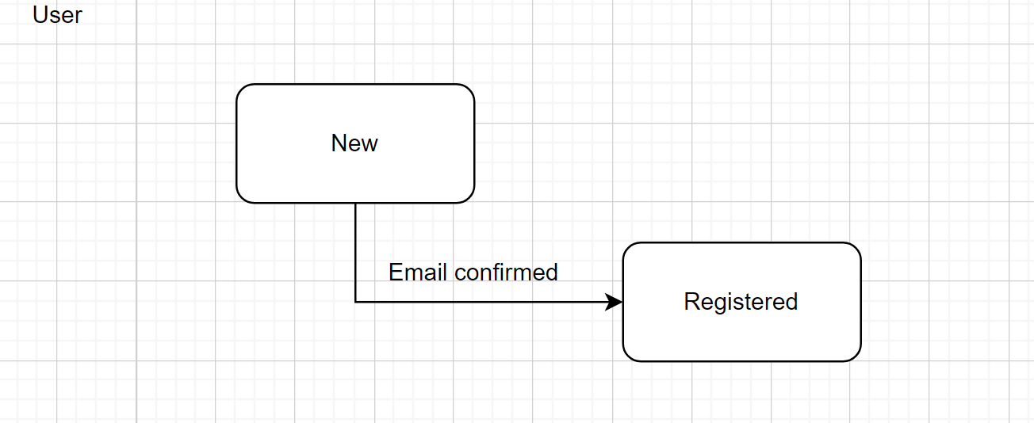

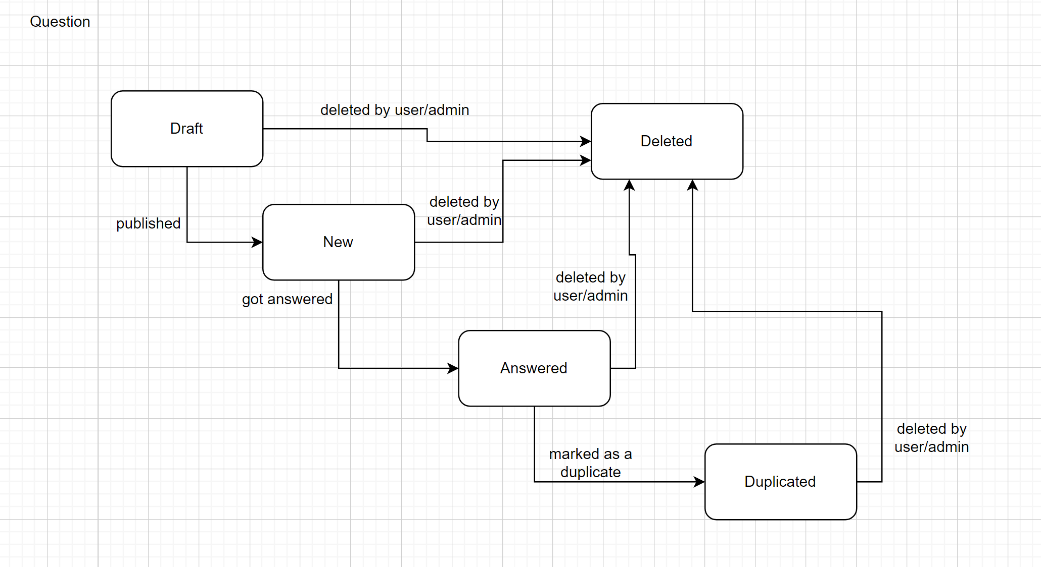

1. **Prepare a final diagrams. Identify any entry and exit actions on the states.**

Edit your previous state diagrams and put new version in this document (as figure).

Note: Here, you use the precise notation in some CASE tool.

Your final diagrams:

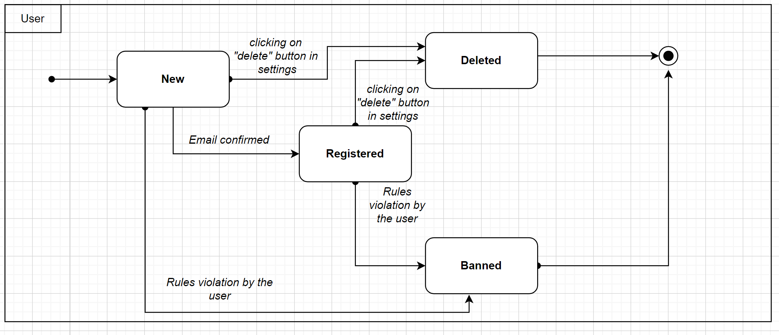

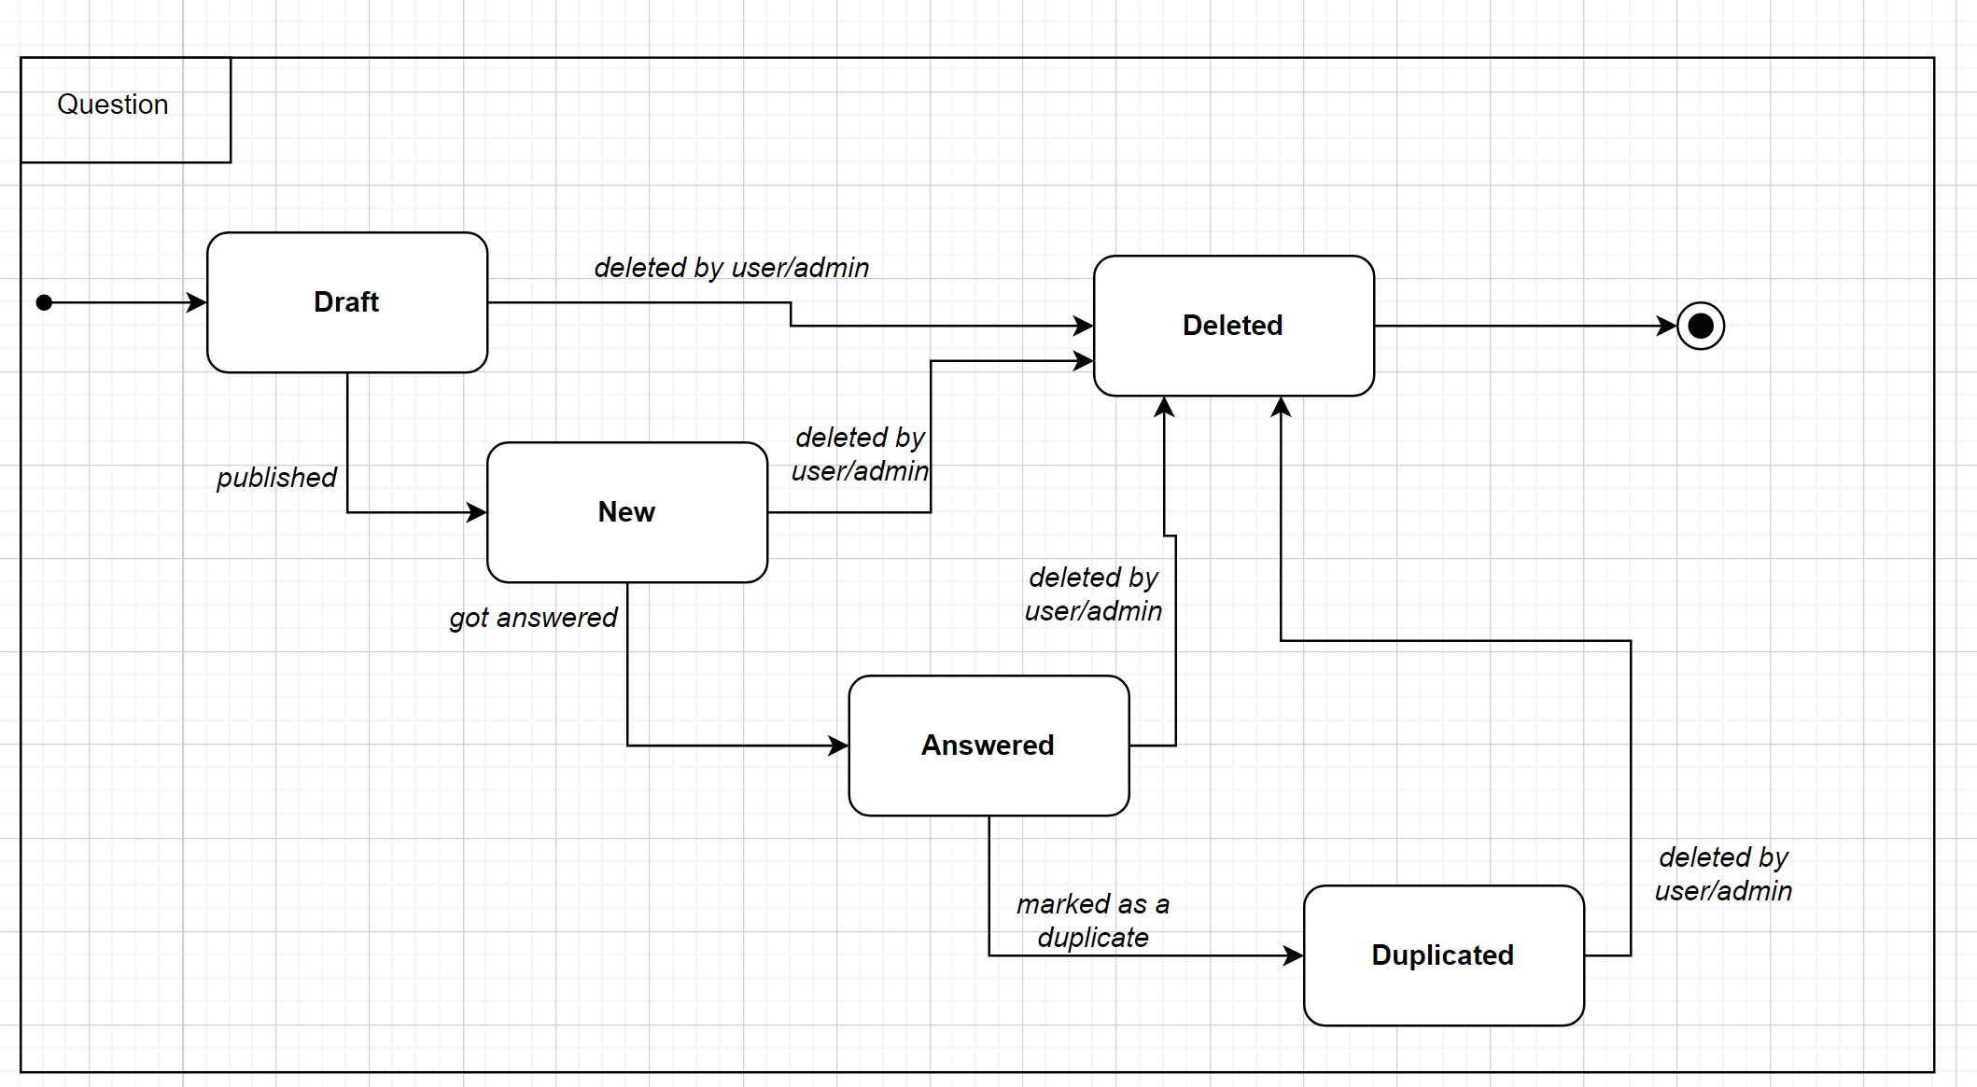

1. **If it is possible, then expand states using substates where necessary.**

(This is optional task).

Your finite state diagram:

1. **Check that the actions in the state are supported by the operations and relationships of the class, and if not extend the class.**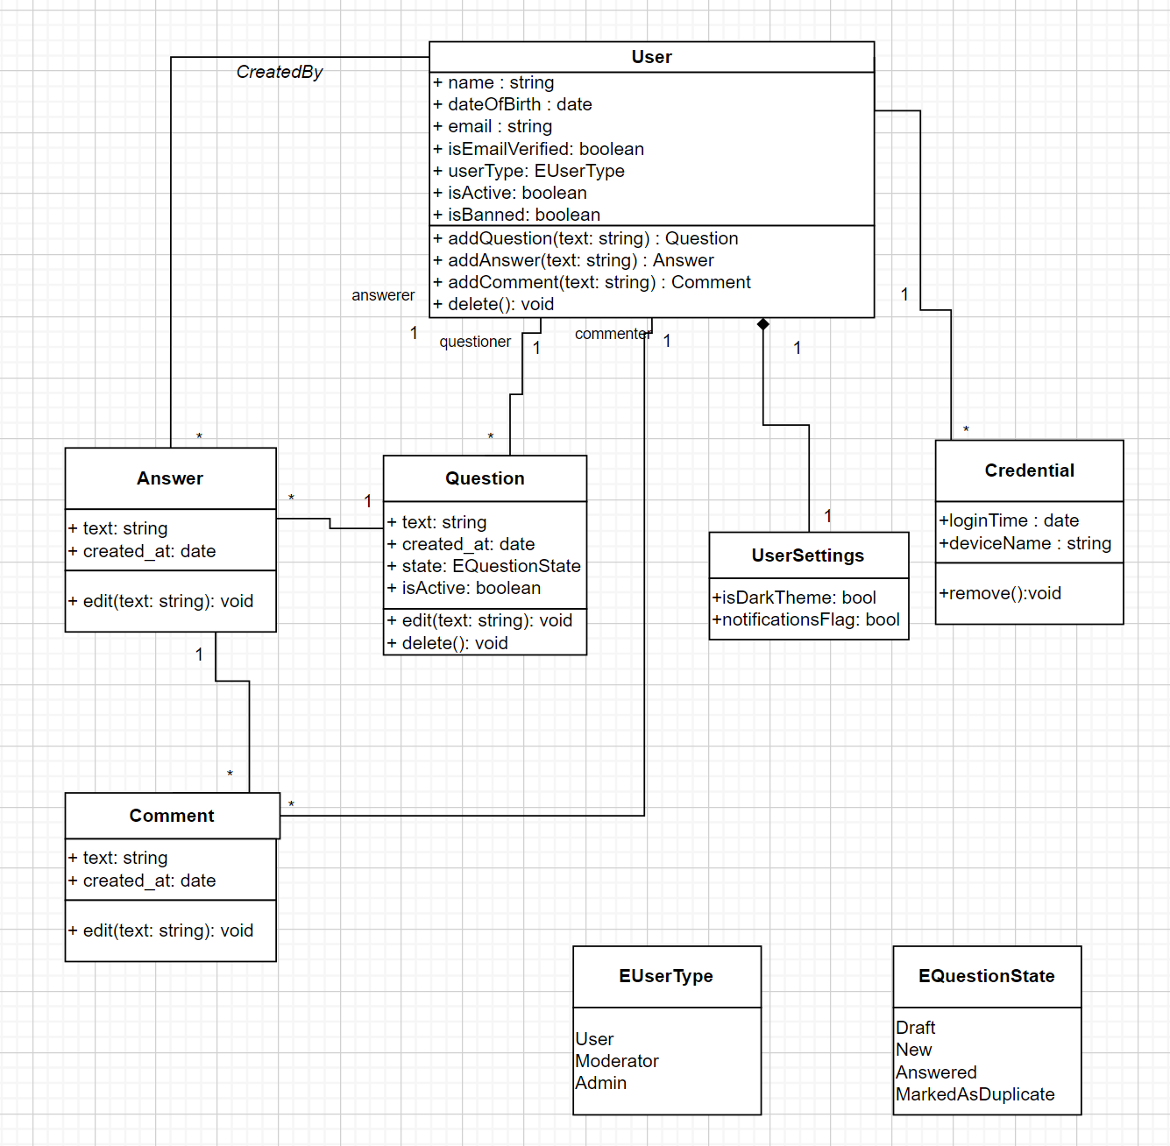
2. **Save the document and upload to the Moodle.**